FOR RELEASE 2PM GMT

TUESDAY 10TH APRIL 2018

KAMASI WASHINGTON’S

HEAVEN & EARTH OUT JUNE 22ND

“FISTS OF FURY” AND “THE SPACE TRAVELERS LULLABY” DEBUT TODAY

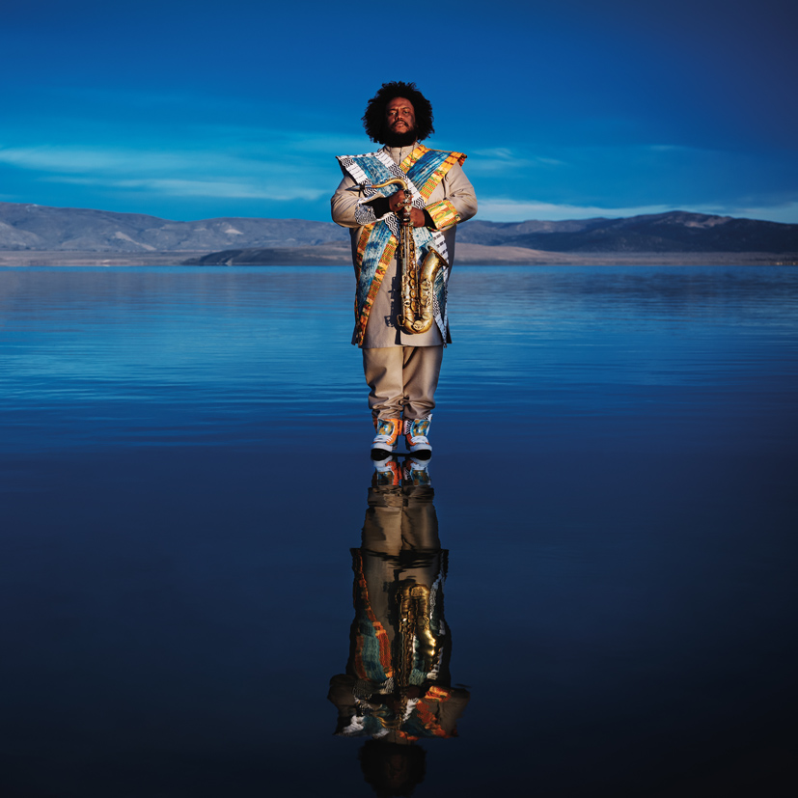

“The world that my mind lives in, lives in my mind.” This idea inspired me to make this album Heaven & Earth. The reality we experience is a mere creation of our consciousness, but our consciousness creates this reality based on those very same experiences. We are simultaneously the creators of our personal universe and creations of our personal universe. The Earth side of this album represents the world as I see it outwardly, the world that I am a part of. The Heaven side of this album represents the world as I see it inwardly, the world that is a part of me. Who I am and the choices I make lie somewhere in between.”

Kamasi Washington

Groundbreaking artist Kamasi Washington’s highly anticipated second album Heaven & Earth is set for release June 22 via Young Turks. Two songs from the double album debut today, listen to Earth’s “Fists of Fury” HERE and Heaven’s “The Space Travelers Lullaby” HERE.

The long-awaited follow up to Washington’s debut The Epic, Heaven & Earth is comprised of two halves, which find Washington confronting quotidian realities with cosmic themes. A further investigation of Washington’s world building ideas, the new album explores his reckoning with current global chaos and his vision for the future.

“Fists of Fury” and “The Space Travelers Lullaby” debut today alongside a pair of accompanying scenes created by acclaimed British artist and director Jenn Nkiru. The rich visual contextualisations are inspired by a more expansive collaborative Heaven & Earth film project that is due for release later in the year.

Watch Jenn Nkiru’s “Fists Of Fury” scene HERE and her “Space Travelers Lullaby” scene HERE

Washington convened his band, The Next Step, as well as members of the long running collective The West Coast Get Down at Henson Studios in Los Angeles to record the 16 tracks on Heaven & Earth. The music was composed, written and arranged by Washington, with new arrangements of jazz and bebop legend Freddie Hubbard’s “Hubtones” and iconic kung fu film theme “Fists of Fury,” as well as one song by bandmate Ryan Porter. Thundercat, Terrace Martin, Ronald Bruner, Jr., Cameron Graves, Brandon Coleman, Miles Mosley, Patrice Quinn, Tony Austin and many more contribute to the album.

Heaven & Earth, over two and a half hours of music, will be available on double deluxe CD and a four piece vinyl housed in bespoke double gatefold sleeve, in addition to all digital services. The album is available to pre-order via http://y-t-r.co/heavenandearth

To celebrate the release of Heaven & Earth, Washington will tour globally. All the dates are listed below with full details available via https://www.kamasiwashington.com/tour/

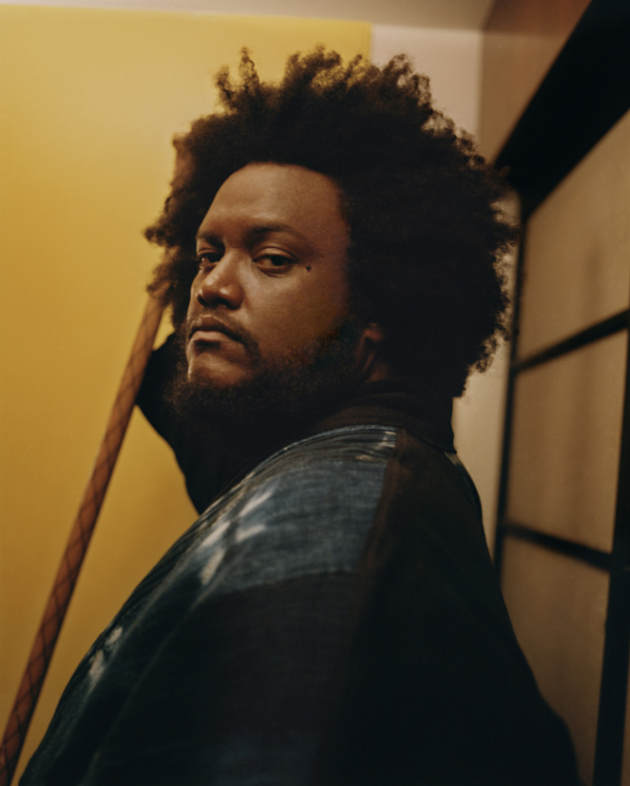

(photo credit: Durimel)

Kamasi Washington is a multi-instrumentalist and producer born and raised in Los Angeles. He grew up playing jazz in the city’s storied Leimert Park neighborhood under the tutelage of his father, Rickey Washington. Forming his first band, the Young Jazz Giants, with Stephen “Thundercat” Bruner, Ronald Bruner, Jr. and Cameron Graves in high school, Washington went on to study ethnomusicology at UCLA and play with Snoop Dogg, Raphael Saadiq and more. His debut album, The Epic, was released in 2015 to rapturous critical reception, universally embraced as one of the best of the year and awarded the inaugural American Music Prize. Heaven & Earth follows The Epic as well as Washington’s 2017 EP Harmony of Difference, an exploration of the musical concept of counterpoint that debuted as an original work for the 2017 Whitney Museum of Art Biennial.

KAMASI WASHINGTON

HEAVEN & EARTH

I. EARTH

1. Fists of Fury
2. Can You Hear Him
3. Hubtones
4. Connections
5. Tiffakonkae
6. The Invincible Youth
7. Testify
8. One of One

II. HEAVEN

9. The Space Travelers Lullaby
10. Vi Lua Vi Sol
11. Street Fighter Mas
12. Song for the Fallen
13. Journey
14. The Psalmnist
15. Show Us the Way
16. Will You Sing

KAMASI WASHINGTON LIVE

April

Sun 15 – Indio, CA - Coachella Music and Arts Festival
Sun 22 – Indio, CA - Coachella Music and Arts Festival
Fri 27 – Morrison, CO – Red Rocks Amphitheater

May

Wed 02 - London, UK - Roundhouse
Fri 04 - Manchester, UK- Albert Hall
Sat 05 - Glasgow, UK - QMU
Sun 06 - Cheltenham, UK - Cheltenham Jazz Festival
Tue 08 - Lyon, France - Nuits Sonores @ Auditorium de Lyon
Wed 09 - Paris, France - Bataclan
Fri 11 - Coutances, France - Jazz Sous les Pommiers @ Salle Marcel Hélie
Sat 12 - St Gaudens, France - Festival Jazz a Comminges @ Parc des Expositions
Sun 13 - Madrid, Spain - Riviera
Mon 14 - Barcelona, Spain - Razzmatazz
Wed 16 - Milan, Italy - Santeria Social Club
Thu 17 - Zurich, Switzerland - Kaufleuten Zurich
Fri 18 - Munich, Germany - Theaterfabrik
Sat 19 - Vienna, Austria - Wiener Konzerthaus
Sun 20 - Diersbach, Austria - INNtone JazzFestival
Tue 22 - Krakow, Poland - Studio
Wed 23 - Prague, Czech Republic - Arhca Theatre
Thu 24 - Warsaw, Poland - Stodola
Fri 25 - Berlin, Germany - Astra
Sun 27 - Cologne, German - Live Music Hall
Mon 28 - Nijmegen, Holland - Doornroosje
Tue 29 - The Hague, Holland - Paard
Wed 30 - Brussels, Belgium - Salle De La Madeleine

June

Fri 01 - Amsterdam, Holland - Paradiso
Sat 02 - Hamburg, Germany - Elbjazz Festival
Sun 03 - Copenhagen, Denmark – Pumpehuset
Fri 15 - New York, NY - Forest Hills Stadium (w/Alt-J)
Sat 16 - Minneapolis, MN - Rock the Garden
Sat 23 - Pasadena, CA - Arroyo Seco
Fri 29 - Waitsfield, VT - Friendly Gathering
Sat 30 - Montreal, Quebec - Festival International de Jazz de Montreal

July
Thu 12 – Berkley, CA – Greek Theater (w/Sylvan Esso)
Wed 25 - Detroit, MI - Chene Park Amphitheater

August

Sat 04 - Dublin, Ireland - Beatyard Festival
Sun 05 - Oxfordshire, UK - Wilderness Festival
Tue 07 - Mainz, Germany - Frankfurter Hof Mainz @ Zitadelle Mainz
Thu 09 - Antwerp, Belgium - Jazz Middelheim
Fri 10 - Copenhagen, Denmark - HAVEN
Sat 11 - Gothenburg, Sweden - Way Out West
Sun 12 - Helsinki, Finland – FLOW
Sat 18 - Tokyo, Japan - Summer Sonic Festival

October

Wed 17 – Seattle, WA – The Showbox
Thu 18 – Portland, OR – Crystal Ballroom
Fri 19 – San Francisco, CA
Sat 20 – San Luis Obispo, CA – Fremont Theater
Mon 22 – Santa Fe, NM – Meow Wolf
Wed 24 – Salt Lake City, UT – Grand Room @ The Complex
Thu 25 – Aspen, CO – Belly Up
Fri 26 – Denver, CO – Ogden Theatre
Sat 27 – Boulder, CO – Boulder Theater
Mon 29 – Kansas City, MO – The Truman
Tue 31 – Iowa City, IA – The Englert Theater

November

Thu 01 – Minneapolis, MN
Fri 02 – Madison, WI
Sat 03 – Chicago, IL – Riviera Theatre
Mon 05 – Toronto, CA – Sony Centre
Wed 07 – Portland, ME – The State Theatre
Thu 08 – Boston, MA – The Royale
Fri 09 – Philadelphia, PA – Electric Factory
Sat 10 – Washington D.C. – Lincoln Theatre
Wed 14 – Richmond, VA – The National
Thu 15 – Raleigh, NC - The Ritz
Fri 16 – Nashville, TN – Marathon Music Works
Sat 17 – Atlanta, GA – Buckhead Theatre

Kamasi Washington
Official / Instagram / Facebook / Twitter

